IPO Setup—Roles

Before using Integrated Purchase Orders (IPO), your users will need **roles** in order to operate the program. Similar to permissions, roles determine which steps of the Requisition/Purchase Order (PO) life-cycle a user can perform, as well as what documents they can work on. Users require at least **1 role** in order to access IPO, but can have as many as needed. Roles are specified by **location** and **department** in order to prevent employees from accessing purchase orders they should not touch, though users can have roles at multiple locations and in multiple departments as needed.

Like permissions, roles are assigned and managed by the **system administrator** in the **Desktop Settings** Admin screens, as are the departments where those roles function. Currently, roles are **only** required for **IPO**/Purchase Orders.

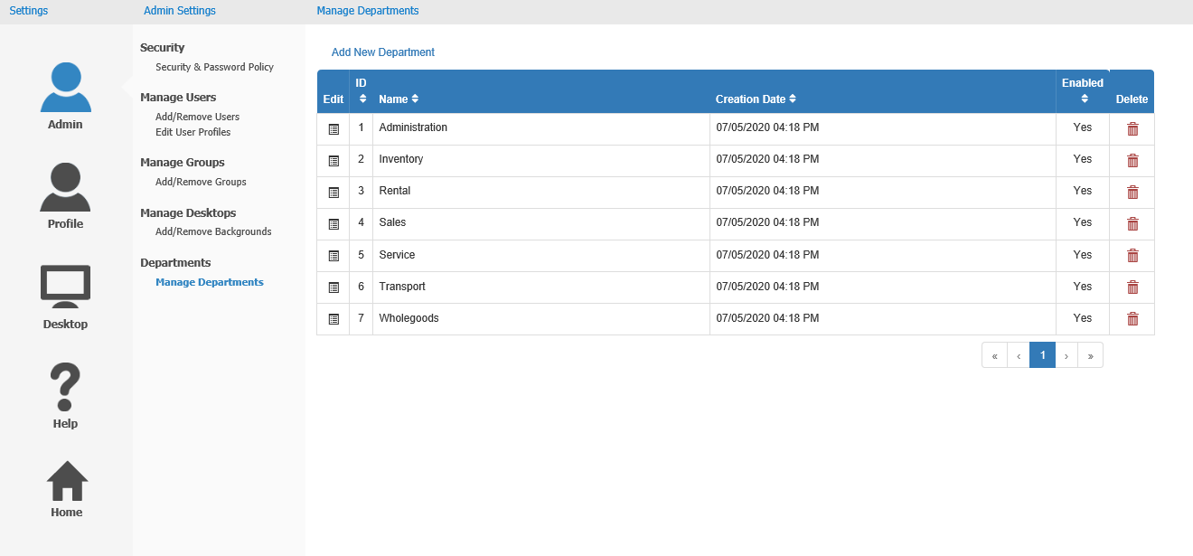

**Manage Departments:** Once you open NetView Settings as a system administrator and select the **Admin** panel, open the **Manage Departments** screen under the Departments heading (pictured above). This screen allows you to manage and create departments for user roles, allowing you to organize which users can make and work on purchase orders for what portion of your business.

Department Grid: Every available role department will appear in this grid. **Seven** departments will exist by **default**, representing the most common departments that might be present in an equipment dealership:

* Administration
* Inventory
* Rental
* Sales
* Service
* Transport
* Wholegoods (Units)

Each department entry will show the following information:

**Edit:** Click this icon to edit the department information. The following window will appear:

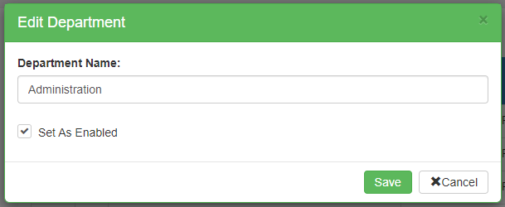

* **Department Name:** This field holds the department name. You can change the name **only if you created the department**—the 7 **default** department names **cannot** be changed.
* **Set As Enabled:** Check this box to enable, or activate, the department for use. This box **must** be checked in order for the department to appear as an option when setting roles and creating purchase orders.
* **Save:** Click this button to save your changes.
* **Cancel:** Click this button to close the window without saving.

**ID:** This column shows the department’s ID number, which is assigned by the system when the department is created. This number is for system-tracking purposes; it will never change and cannot be edited.

**Name:** This column shows the department name.

**Creation Date:** This column shows the date and time the department was created.

**Enabled:** This column indicates whether or not the department is currently enabled.

* If the column reads **“Yes,”** the department is currently enabled.
* If the column reads **“No,”** the department is disabled and unavailable for use.

**Delete:** This column holds the Delete icon for the department entry. It will **only activate** if the department is **disabled**, was **never used** for **any role** listed on **any document**, and is **not** one of the seven **default** departments. Click on it to delete the department from the system. The following warning will appear:

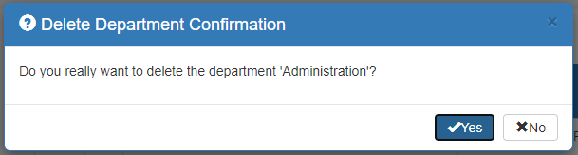

Click **Yes** to delete the department.

**NOTE:** If for any reason the display is too large for your monitor or laptop screen, some of the columns will be **hidden** in order to fit the grid in the display. If any columns have been hidden, a **“+”** icon will appear next to the Edit icon. Click it to view any hidden column data, and click it a second time to re-hide the data.

Add New Department: If your business contains departments that do not match any of the seven defaults, you can add more departments using the **Add New Department** feature. Click on the words above the grid to open the following window:

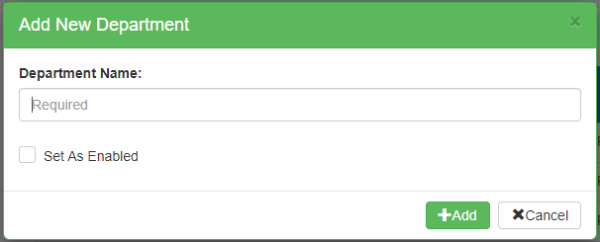

Enter the department name and click “Set as Enabled” to make it active, then click **Add**. The new department will then appear in the Department Grid listing and be available for roles and purchase orders.

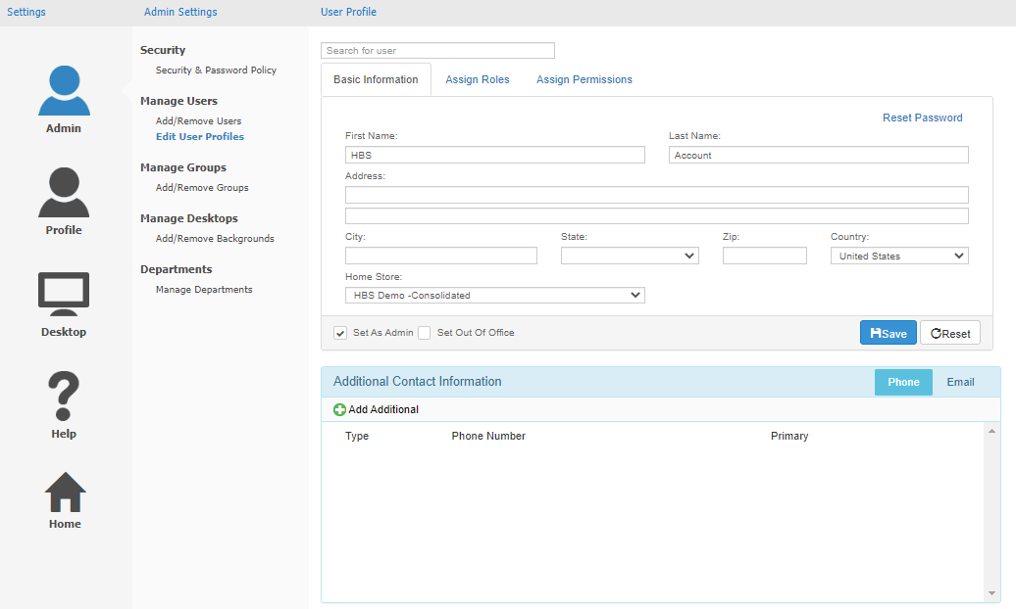

**Assign Roles:** Once you have all the departments set up, go to the **Edit User Profiles** screen under the “Manage Users” heading. Locate the user you want to work on by entering all or part of their name or user ID in the **Search for User** field at the top of the screen. A list of users will appear below the field as you type; select the user once you see them to open their profile.

Once you select a user’s profile, click the **Assign Roles** tab to view, assign, and manage their roles.

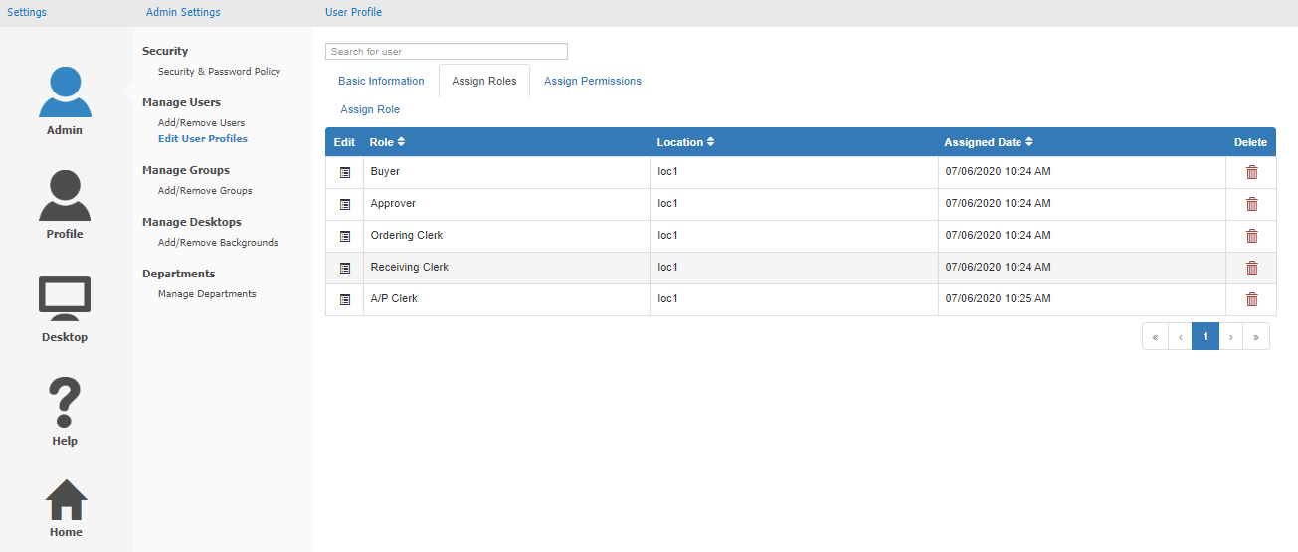

Roles Grid Columns: The user’s current roles will be listed in a grid. **NOTE:** If for whatever reason your screen resolution is smaller than average, the grid may **compact** and hide column information on a **subline**. If this occurs, a “**+**” icon will appear in the far left column of the grid entry; clicking on it will reveal the rest of the information.

**Role:** This column shows the role assigned. As roles currently only exist for **Purchase Orders** (in IPO), the role will be one of the following:

* **Buyer:** The **Buyer** role is responsible for creating Requisitions (purchase order requests) and submitting them to become Purchase Orders. They are able to edit Requisitions as long as they have an “Open” status. However, they **cannot** work on Purchase Orders, and they are **restricted** by limits on how much money they can request on both a **single Requisition** and over the course of a **day**.
  + If they remain **within** their limits, they will be able to convert Requisitions into Purchase Orders without any outside approval.
  + If they **exceed** their limits, however, they will need to submit their Requisitions to an **Approver** for review.
* **Approver:** The **Approver** role is only needed if a Buyer exceeds their set limits on Requisitions. They must review any Requisitions with a “Pending Approval” status, and decide whether to approve or deny the purchase request. They can **only** act on **Pending Approval Requisitions**, and like Buyers they are **restricted** by limits on the monetary amounts they can approve on both a **single Requisition** and over the course of a **day**. Approvers can only approve Requisitions until they reach their limits; after that point, they will have to leave the job to other Approvers.
  + If an Approver ever **exceeds** their limits while approving a Requisition, that Requisition will have to be submitted again to an Approver with **higher** limits.
* **Ordering Clerk:** The **Ordering Clerk** role’s job is to perform the **Order** step on Purchase Orders, though they can also perform other actions (see the topics for **Integrated Purchase Orders (IPO)** for more information). This step requires that they mark all lines on the document as actually ordered (or not being ordered) from the vendor, and record any changes in price or quantity from the original Requisition in order to maintain accurate accounting. **NOTE:** The Order step can be **disabled** via a program setting on all PO types **except for Unit Purchase Orders**.
* **Receiving Clerk:** The **Receiving Clerk** role must perform the **Receive** step on Purchase Orders, though they can also perform other actions (see the topics for **Integrated Purchase Orders (IPO)** for more information). This step requires that they record on the Purchase Order that the physical items ordered have **physically** arrived at the dealership, and record the quantities received from the packing slip provided by the vendor, noting what was and was not delivered. **NOTE:** The **Receive** step can only be performed after the **Order** step is completed and at least some of the items on the PO have been delivered.
* **A/P Clerk:** The **A/P Clerk** role must perform the **Reconcile** step on Purchase Orders, which is the final step in processing a PO, though they can also perform other actions (see the topics for **Integrated Purchase Orders (IPO)** for more information). This step requires that they put in the actual cost of the Purchase Order from the vendor invoices and account for any discrepancies between the cost as originally ordered and what the dealership ended up paying. They will also actually do the order’s accounting, recording in the system how the invoices were/will be paid, and how much of the payments went to which accounts. **NOTE:** The **Reconcile** step can only be performed after the **Receive** step is completed for the items on the vendor invoices, and the document will **close** once the step is completed for **all** line items.

**Location:** This column shows the dealer location where the user role is valid, i.e. where they have permissions to use it.

**Assigned Date:** This column shows the date and time that a system admin assigned that role to the user.

**Delete:** This column holds the red **Delete** icon for the role. Click it at any time to **delete** the user’s role. The following window will appear:

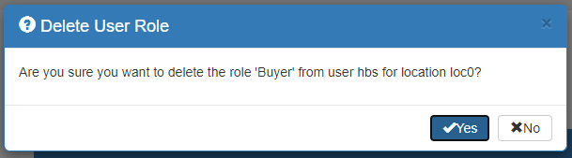

Click **Yes** to delete the role.

Assign Role: To **add** a new role to the user’s profile, click **Assign Role** just above the grid. The following window will open:

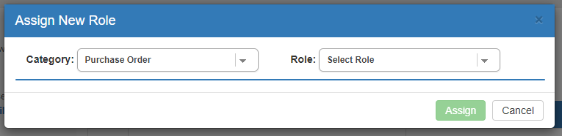

Right now, the only Role Category available to select is **Purchase Order**, meaning only permissions for **IPO** are currently given via roles (all other permissions are still handled by **system admins** in **User and Permission File Setup (PERM)**). Use the **Role** dropdown to select which Purchase Order role you want the user to have, which will determine what other information you need to select.

**Assign Buyer Role:** If you select **Buyer**, the following fields will appear:

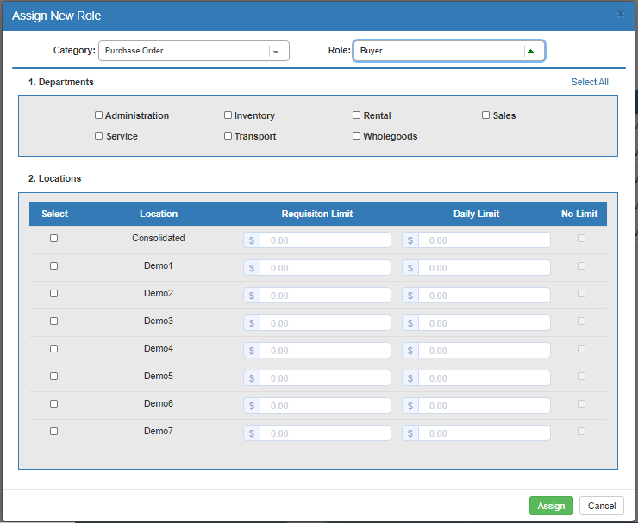

* **Departments:** Select which Departments you want the user to have a Buyer role in. If you want the role to work for **all** available Departments, click **Select All** to check all the Department boxes.
* **Locations:** Select which dealer locations you want the user’s Buyer role to function at.
* **Limits:** Once you select a location, the **Limit** fields connected to it will activate. Set what limits you want the Buyer to have at that location. Once they **exceed** these limits, they will have to submit all further Requisitions for approval.
  + **Requisition Limit:** This limit sets how much money the Buyer can request on a **single Requisition** at a time.
  + **Daily Limit:** This limit sets how much money the Buyer can request during a **single day**, meaning the total value of all Requisitions they can submit during that time.
  + **No Limits:** If you don’t want the Buyer to have any limit to the amount of money they can request, check this box. The other Limit fields will show **“No Limit”** and **deactivate**. Leave the box unchecked to require limits for the Buyer. **NOTE:** A Buyer with “No Limits” will have **no oversight**. Please keep this in mind when assigning Buyer roles.

**Assign Approver Role:** If you select the **Approver** role, the following fields will appear:

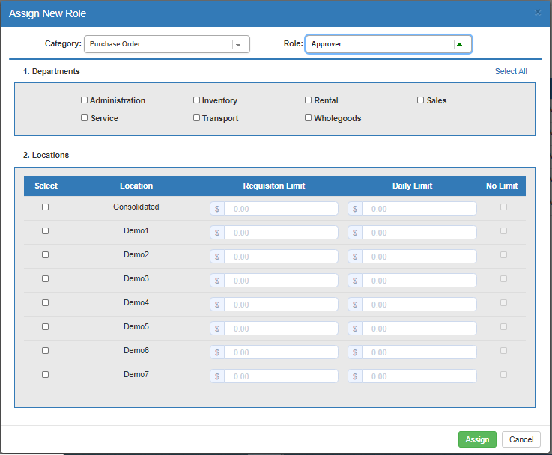

* **Departments:** Select which Departments you want the user to have an Approver role in. If you want the role to work for **all** available Departments, click **Select All** to check all the Department boxes.
* **Locations:** Select which dealer locations you want the user’s Approver role to function at.
* **Limits:** Once you select a location, the **Limit** fields connected to it will activate. Set what limits you want the Approver to have at that location. Once they **exceed** these limits, any Requisition they approve will require approval from an Approver with **higher** limits.
  + **Requisition Limit:** This limit sets how much money the Approver can approve on a **single Requisition** at a time.
  + **Daily Limit:** This limit sets how much money the Approver can approve during a **single day**, meaning the total value of all Requisitions they can approve during that time.
  + **No Limits:** If you don’t want the Approver to have any limit to how much they can approve, check this box. The other Limit fields will show **“No Limit”** and **deactivate**. Leave the box unchecked to require limits for the Approver. **NOTE:** Approvers with “No Limits” are by default the **highest** rank of Approver that a Requisition will require approval from, and thus have **no oversight**. Please keep this in mind when assigning Approver roles.

**Assign Ordering Clerk Role:** If you select the **Ordering Clerk** role, the following fields will appear:

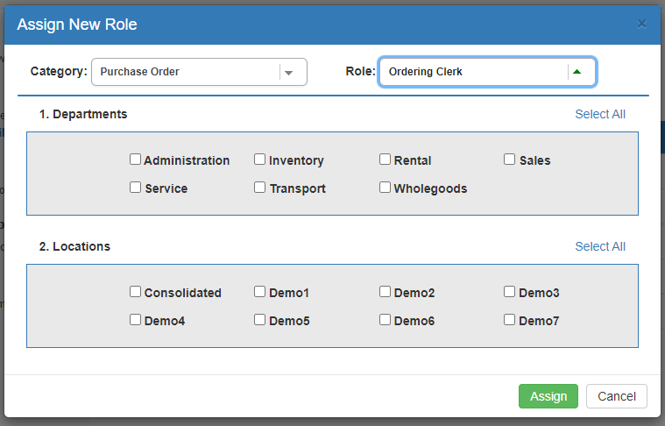

* **Departments:** Select which Departments you want the user to have an Ordering Clerk role in. If you want the role to work for **all** available Departments, click **Select All** to check all the Department boxes.
* **Locations:** Select which dealer locations you want the user’s Ordering Clerk role to function at.

**Assign Receiving Clerk Role:** If you select the **Receiving Clerk** role, the following fields will appear:

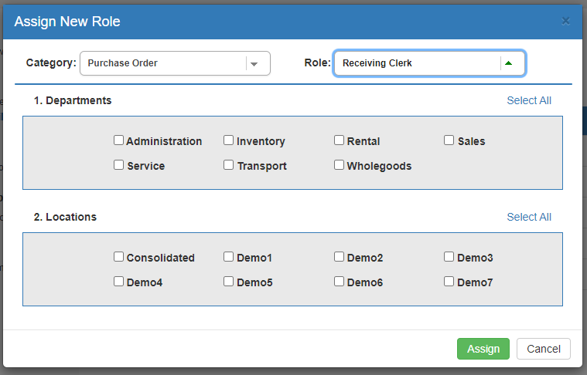

* **Departments:** Select which Departments you want the user to have a Receiving Clerk role in. If you want the role to work for **all** available Departments, click **Select All** to check all the Department boxes.
* **Locations:** Select which dealer locations you want the user’s Receiving Clerk role to function at.

**Assign A/P Clerk Role:** If you select the **A/P Clerk** role, the following fields will appear:

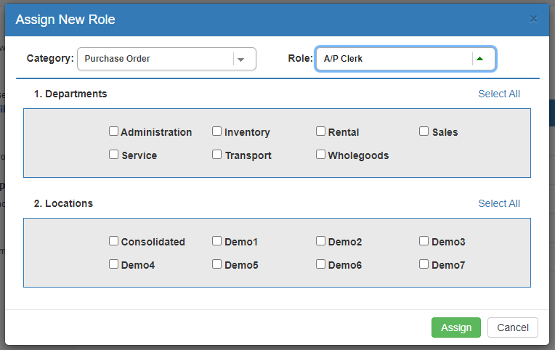

* **Departments:** Select which Departments you want the user to have an A/P Clerk role in. If you want the role to work for **all** available Departments, click **Select All** to check all the Department boxes.
* **Locations:** Select which dealer locations you want the user’s Receiving Clerk role to function at.

Once you have the selected role set up as desired, click **Assign** to add the role to the user’s profile. You will be returned to the **Assign Roles** screen, where the new role will appear in the grid listing. **NOTE:** If you added the role for **multiple locations**, you will see a role entry in the grid for **each location**. As such, if you want to remove the user’s role for a **single location only,** all you need to do is **delete** the role for that location.



Edit Role: If you need to **edit** a user’s role for any reason, click the **Edit** icon in the far-left column of the role’s entry to open the **Edit Role** screen. The screen will have different fields based on which role you are editing.

**Edit Buyer or Approver:** When editing a **Buyer** or **Approver** role, the screen will look like this:

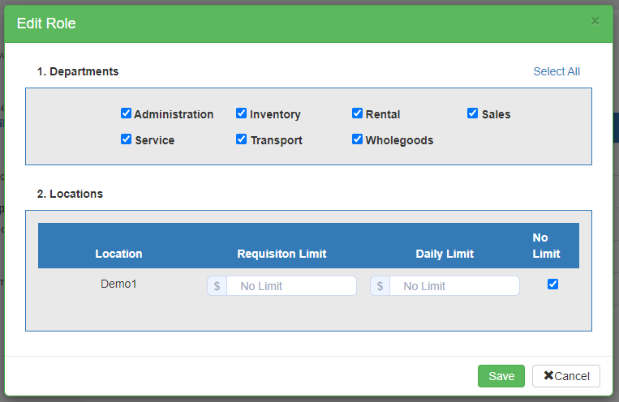

Make any desired changes to the user’s permissions.

**Edit Ordering/Receiving/AP Clerk:** When editing an **Ordering Clerk, Receiving Clerk,** or **A/P Clerk** role, the screen will look like this:

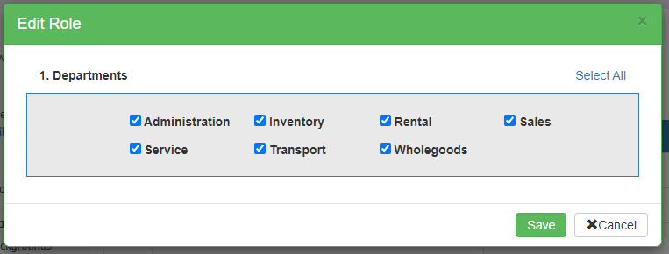

Make any desired changes to the user’s permissions.

**Save:** When you have finished editing the selected role, click **Save** to close the screen and save your changes.